FAKULTAS ILMU SOSIAL ILMU POLITIK

LAPORAN KEGIATAN PERKULIAHAN
Tahun Akademik 2019 / 2020

Nama Dosen : Tria Patrianti, S.Sos., M.I.Kom
Mata Kuliah :INTEGRATED MARKETING COMMUNICATION
Status : Dosen
Semester : Genap
Bobot Kredit : 2 SKS

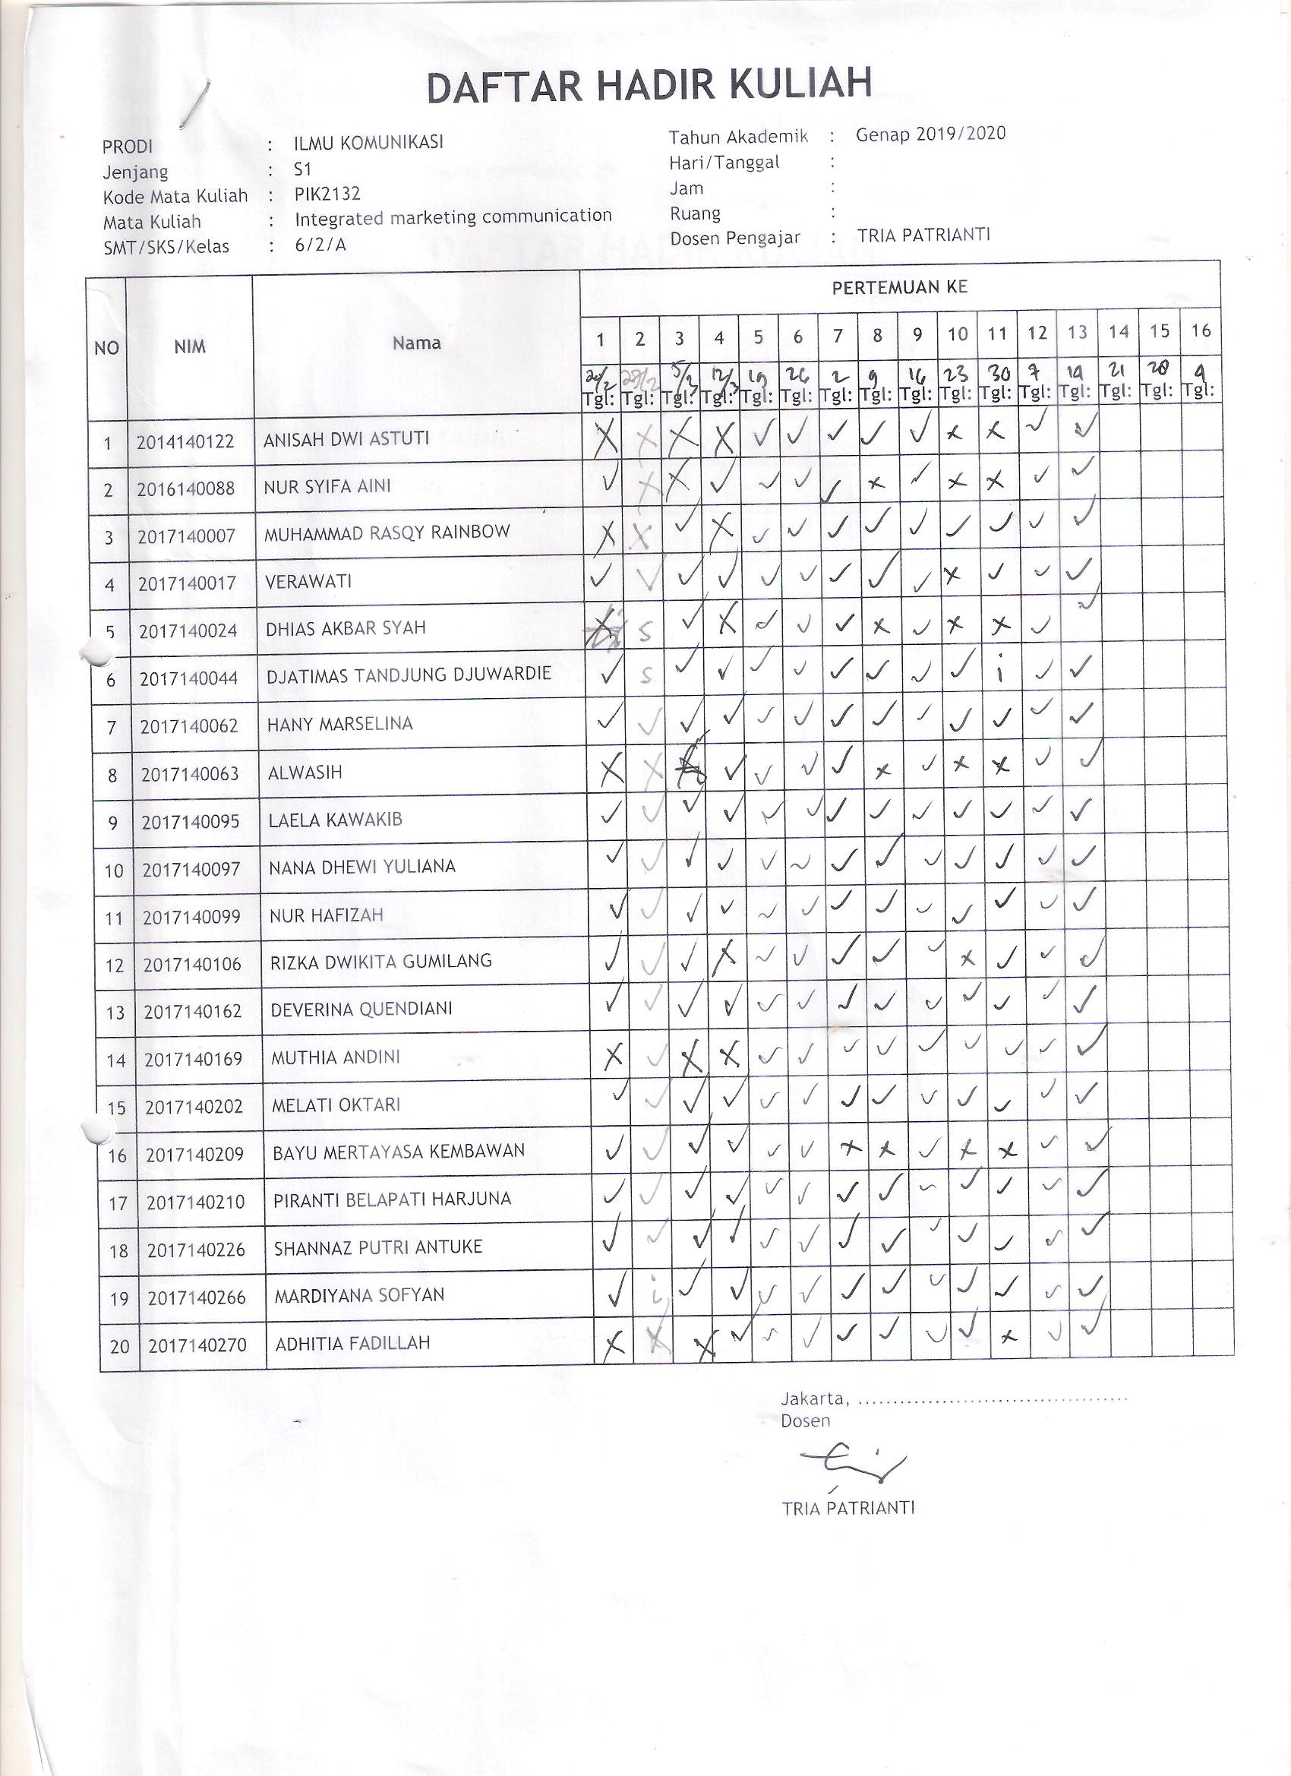

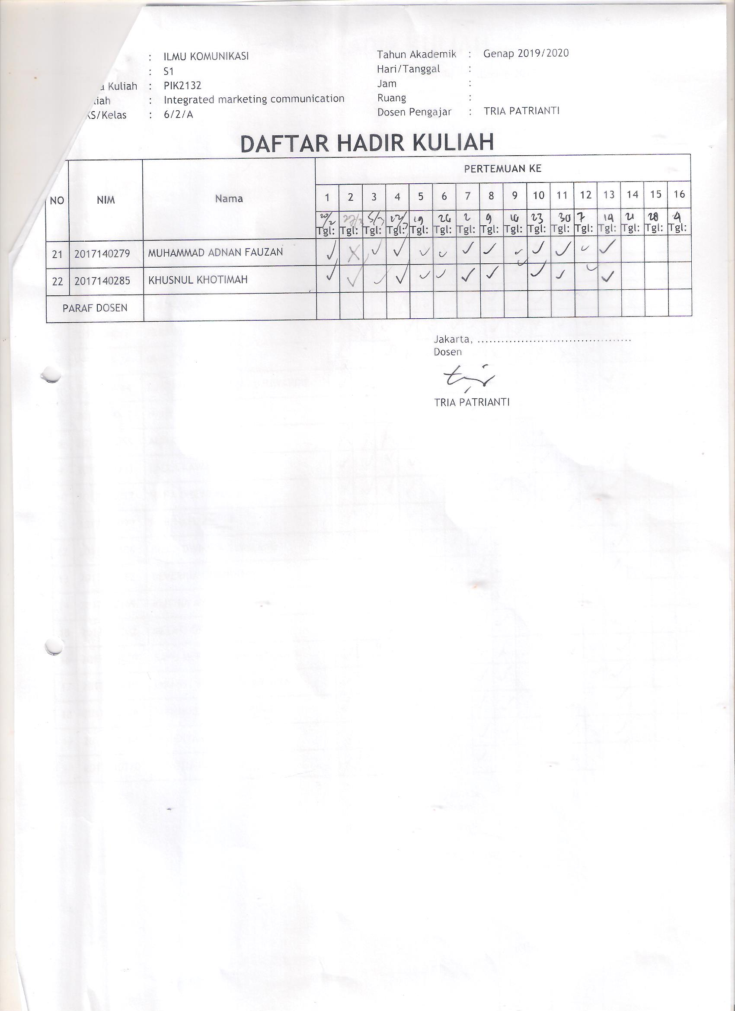

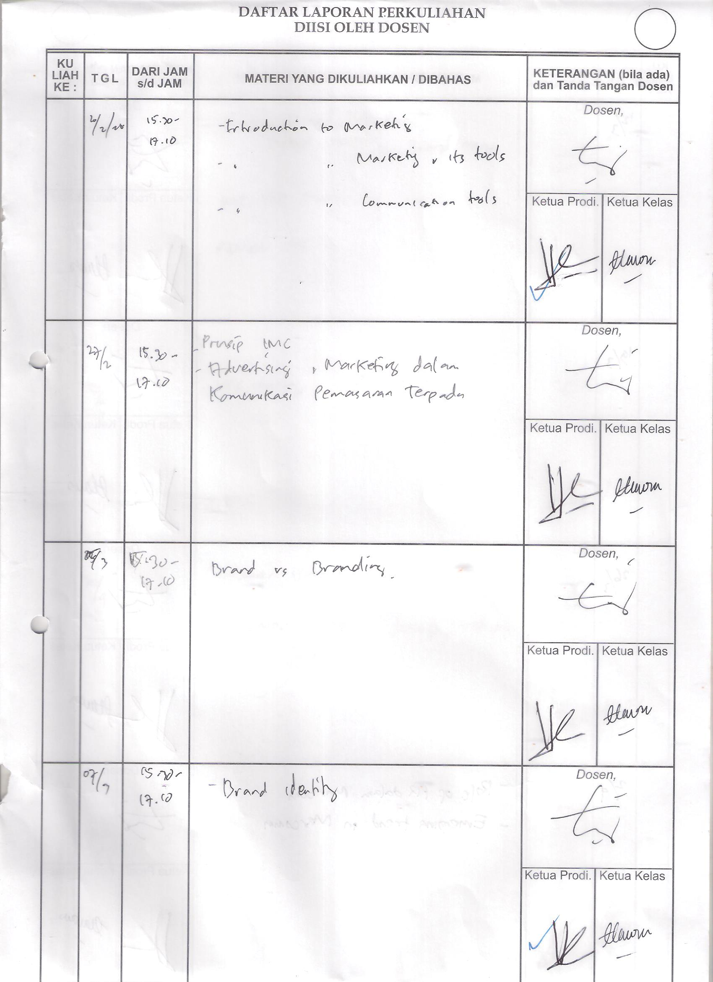

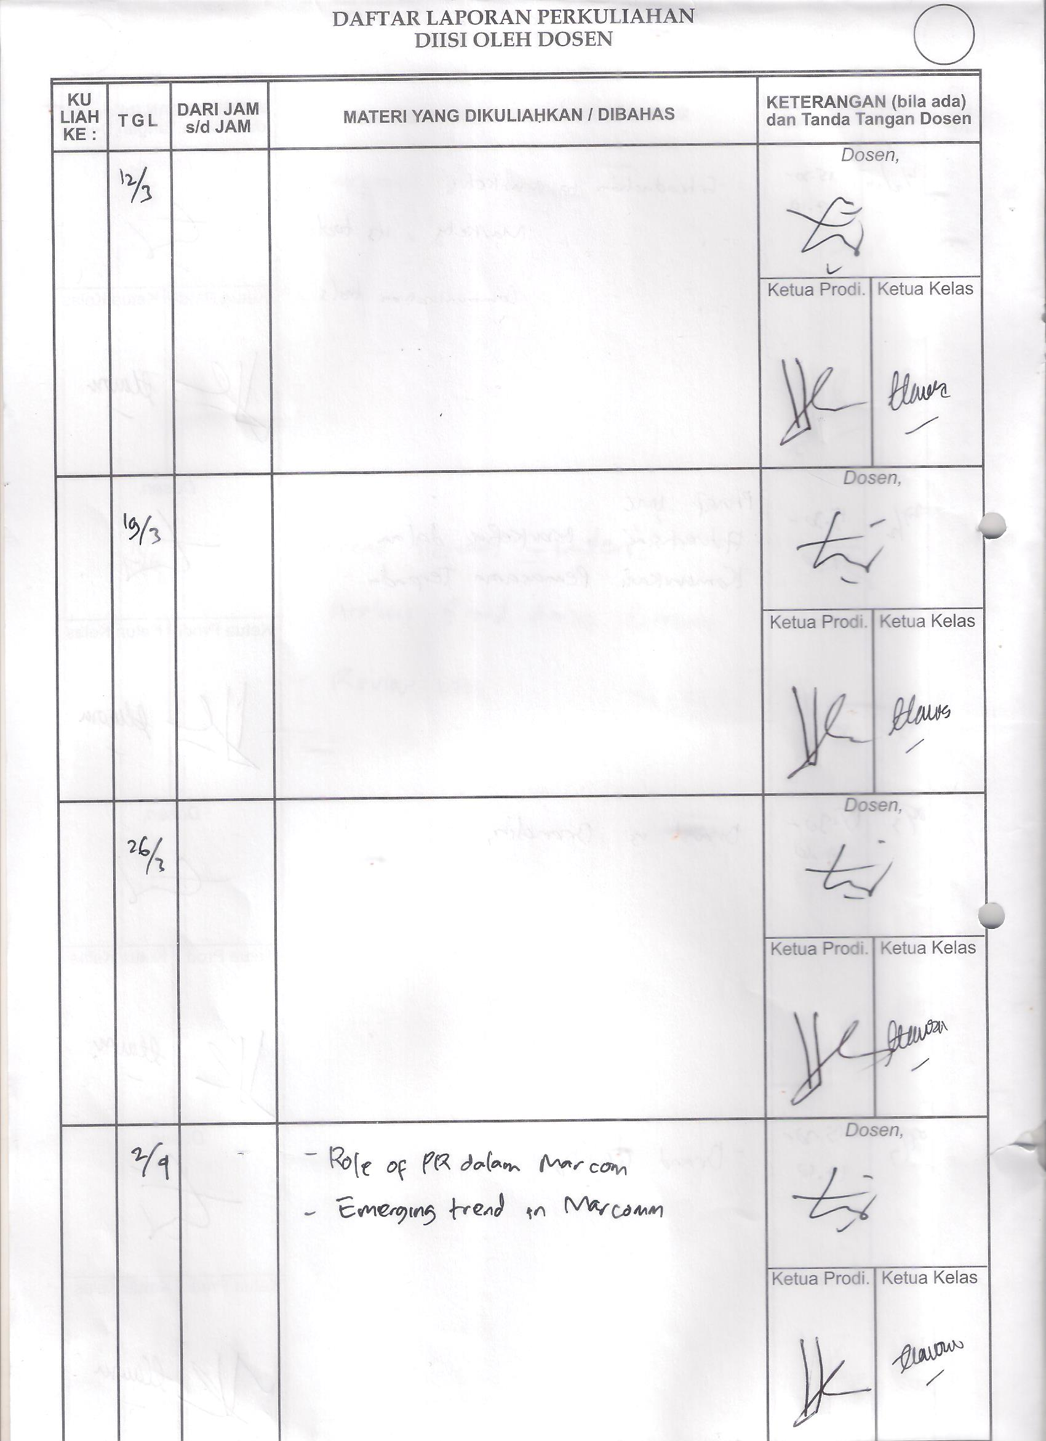
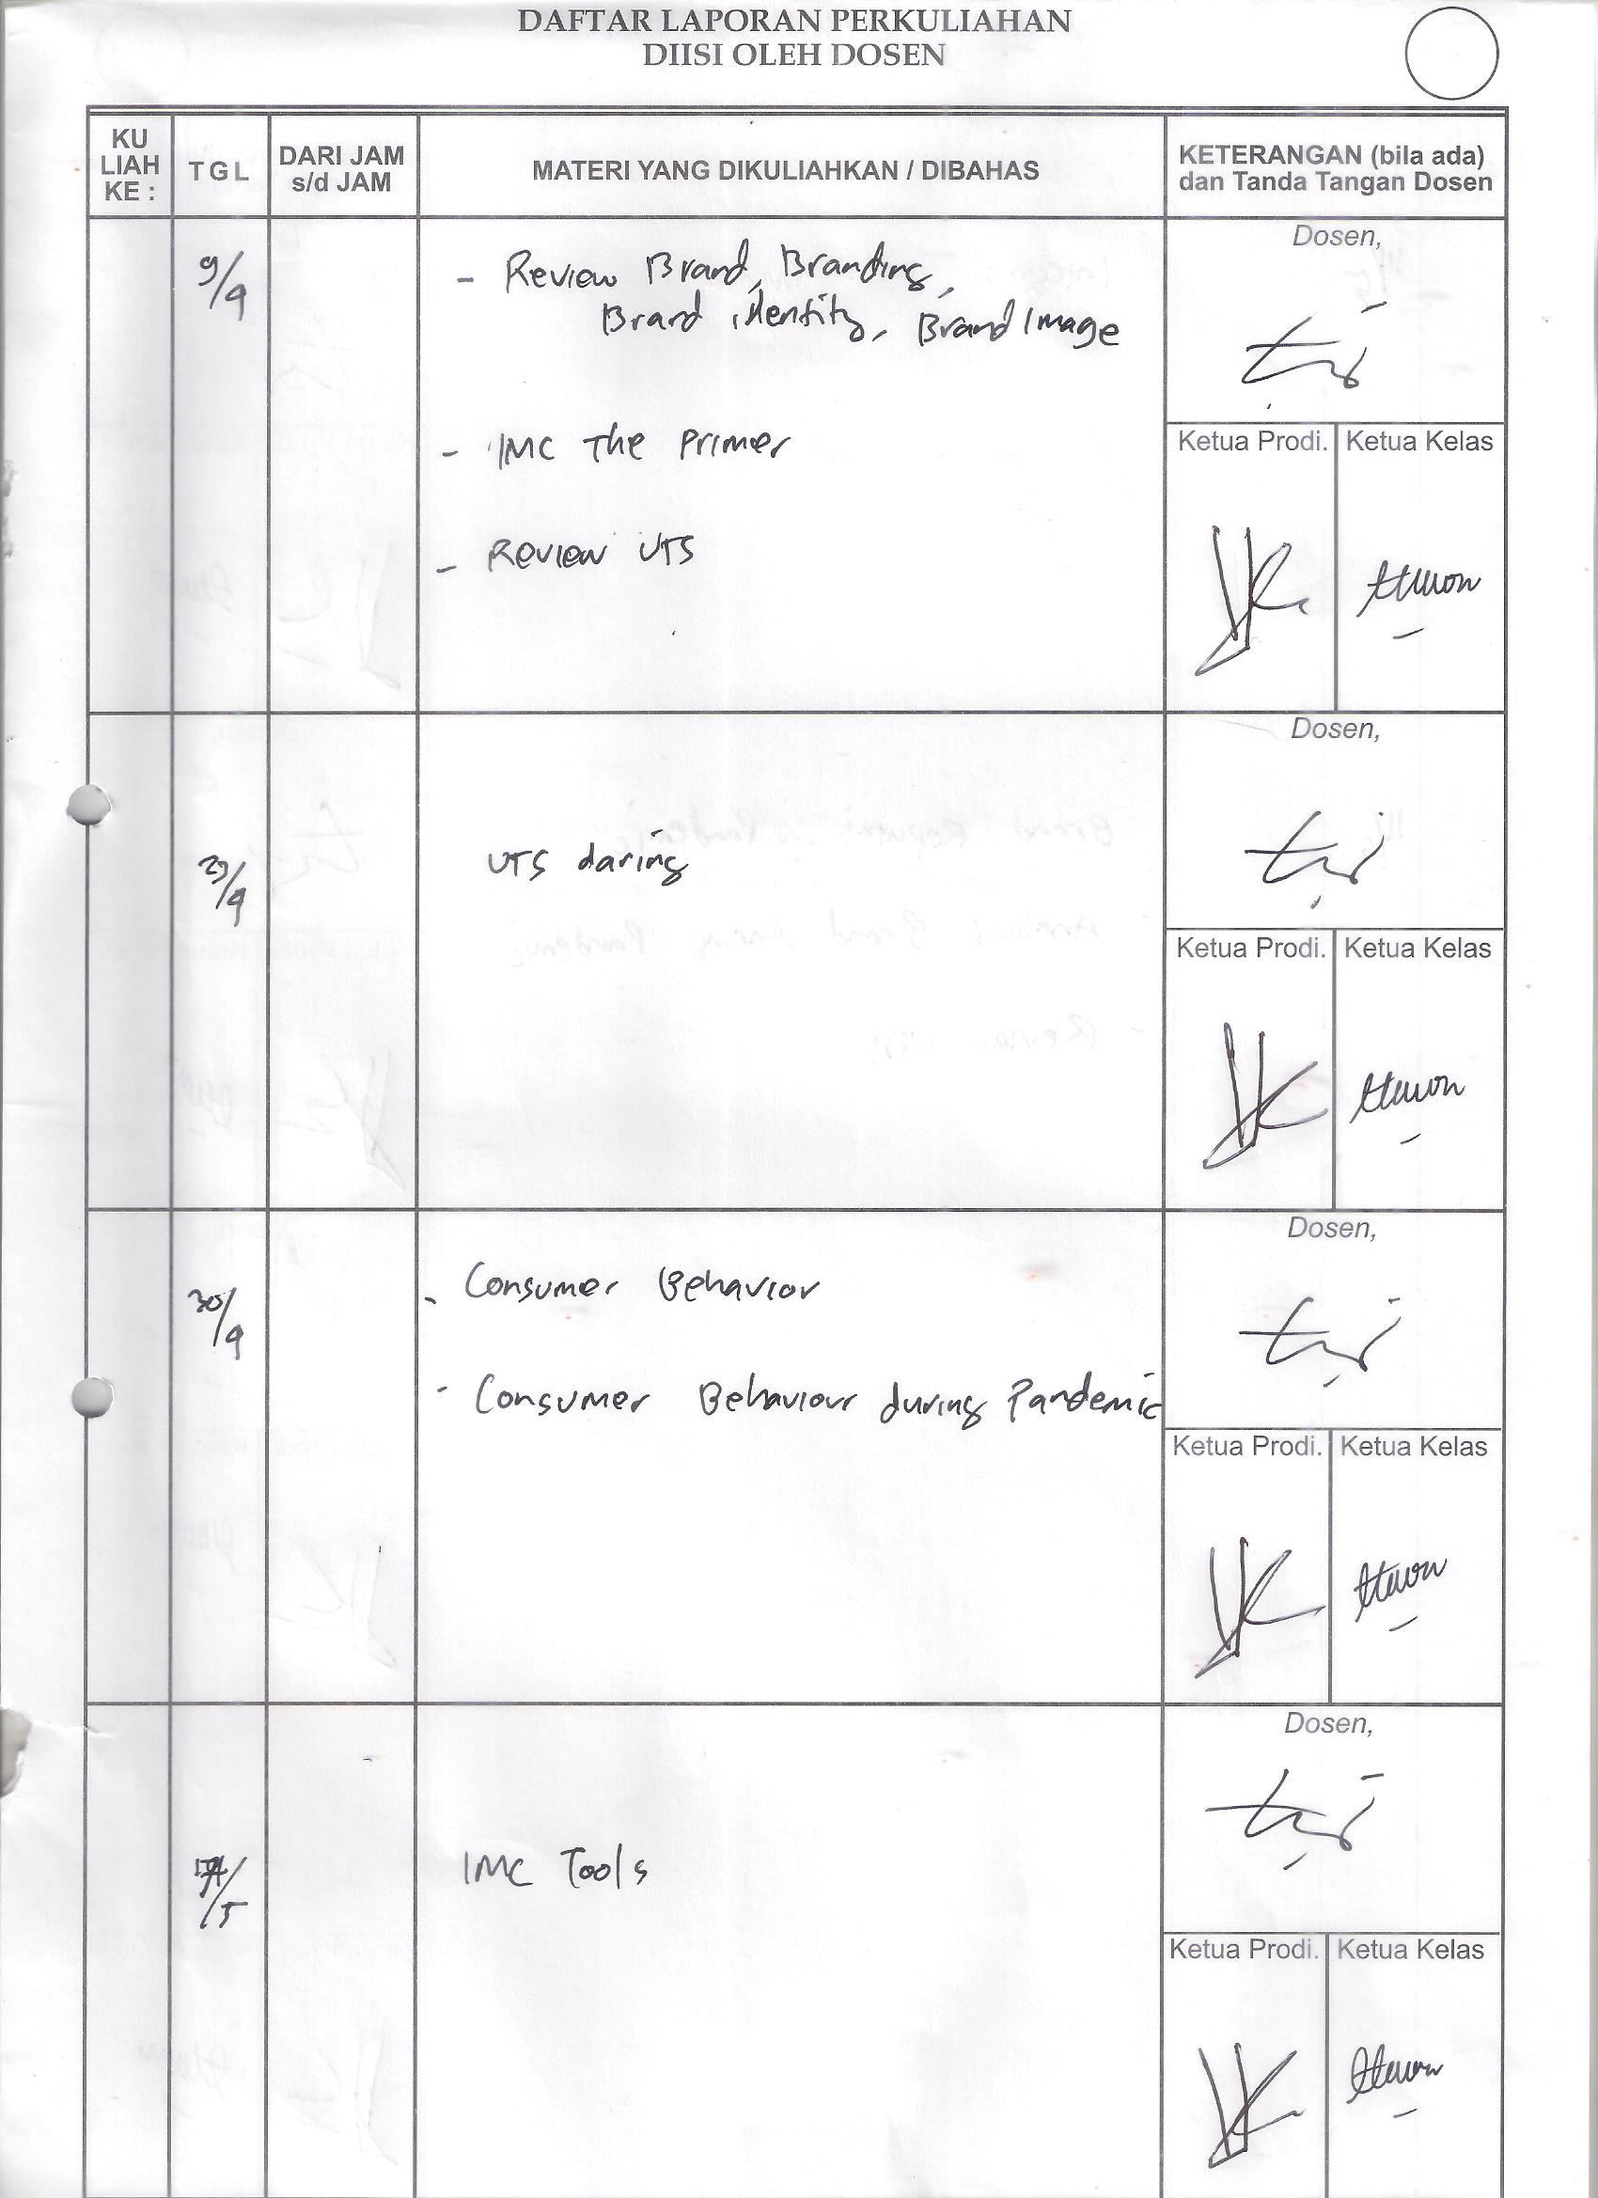

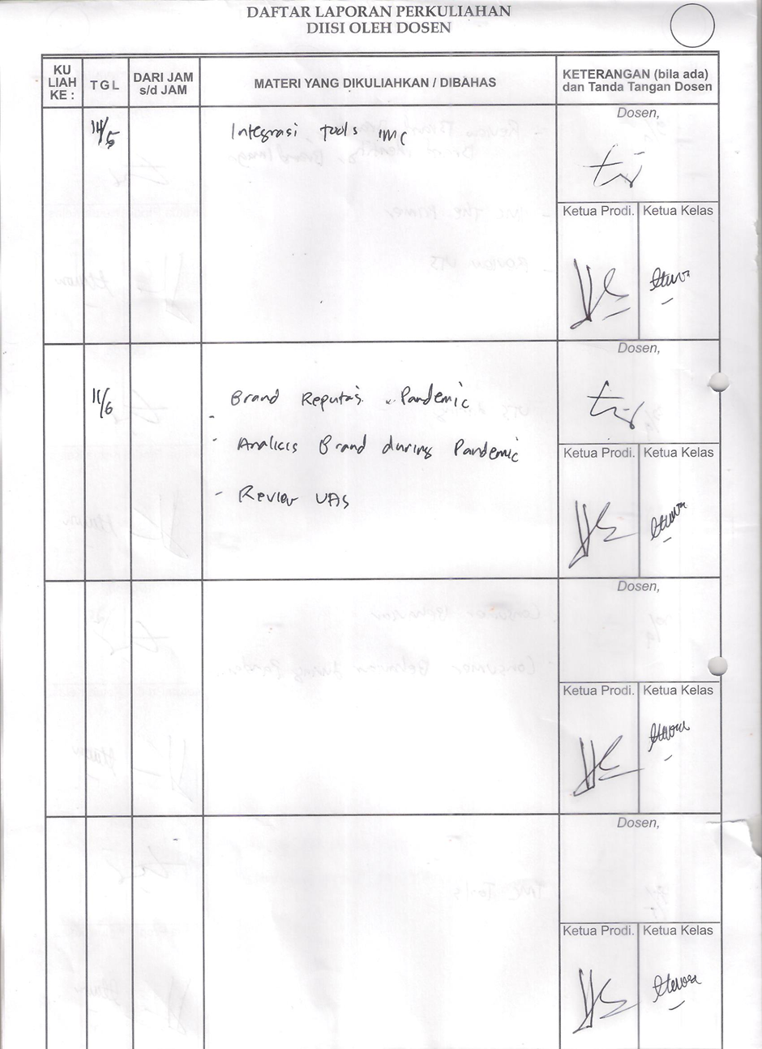

Batas Akhir Entri Nilai | :
Prodi | : 70201 - ILMU KOMUNIKASI ( S1 )
Mata Kuliah | : PIK2132, Integrated marketing communication
Tahun Akademik | : 2019/2020
Semester | : Genap
Dosen Pengajar | : 031011018, TRIA PATRIANTI
Kode Kelas | : A

No | NIM | Nama | FORMATIF  (30.00%) | UTS  (30.00%) | UAS  (40.00%) | Nilai Akhir/ (Asli) | Bobot Hitung/ (Asli) | Simbol Hitung/ (Asli)
1 | 2014140122 | ANISAH DWI ASTUTI | 0.00 | 0.00 | 0.00 | 0.00 (0.00) | 0.00 (0.00) | E (E)
2 | 2016140088 | NUR SYIFA AINI | 70.00 | 70.00 | 70.00 | 70.00 (70.00) | 3.00 (3.00) | B (B)
3 | 2017140007 | MUHAMMAD RASQY RAINBOW | 80.00 | 83.00 | 80.00 | 80.90 (80.90) | 3.70 (3.70) | A- (A-)
4 | 2017140017 | VERAWATI | 85.00 | 80.00 | 80.00 | 81.50 (81.50) | 3.70 (3.70) | A- (A-)
5 | 2017140024 | DHIAS AKBAR SYAH | 80.00 | 70.00 | 75.00 | 75.00 (75.00) | 3.30 (3.30) | B+ (B+)
6 | 2017140044 | DJATIMAS TANDJUNG DJUWARDIE | 85.00 | 88.00 | 85.00 | 85.90 (85.90) | 4.00 (4.00) | A (A)
7 | 2017140062 | HANY MARSELINA | 85.00 | 85.00 | 80.00 | 83.00 (83.00) | 3.70 (3.70) | A- (A-)
8 | 2017140063 | ALWASIH | 0.00 | 0.00 | 0.00 | 0.00 (0.00) | 0.00 (0.00) | E (E)
9 | 2017140095 | LAELA KAWAKIB | 85.00 | 80.00 | 75.00 | 79.50 (79.50) | 3.30 (3.30) | B+ (B+)
10 | 2017140097 | NANA DHEWI YULIANA | 85.00 | 85.00 | 80.00 | 83.00 (83.00) | 3.70 (3.70) | A- (A-)
11 | 2017140099 | NUR HAFIZAH | 85.00 | 80.00 | 80.00 | 81.50 (81.50) | 3.70 (3.70) | A- (A-)
12 | 2017140106 | RIZKA DWIKITA GUMILANG | 85.00 | 80.00 | 75.00 | 79.50 (79.50) | 3.30 (3.30) | B+ (B+)
13 | 2017140162 | DEVERINA QUENDIANI | 85.00 | 88.00 | 85.00 | 85.90 (85.90) | 4.00 (4.00) | A (A)
14 | 2017140202 | MELATI OKTARI | 85.00 | 88.00 | 85.00 | 85.90 (85.90) | 4.00 (4.00) | A (A)
15 | 2017140209 | BAYU MERTAYASA KEMBAWAN | 80.00 | 70.00 | 70.00 | 73.00 (73.00) | 3.00 (3.00) | B (B)
16 | 2017140210 | PIRANTI BELAPATI HARJUNA | 85.00 | 85.00 | 85.00 | 85.00 (85.00) | 4.00 (4.00) | A (A)
17 | 2017140226 | SHANNAZ PUTRI ANTUKE | 85.00 | 75.00 | 80.00 | 80.00 (80.00) | 3.70 (3.70) | A- (A-)
18 | 2017140246 | ADITYA KURNIAWAN | 80.00 | 75.00 | 75.00 | 76.50 (76.50) | 3.30 (3.30) | B+ (B+)
19 | 2017140266 | MARDIYANA SOFYAN | 85.00 | 82.00 | 75.00 | 80.10 (80.10) | 3.70 (3.70) | A- (A-)
20 | 2017140270 | ADHITIA FADILLAH | 80.00 | 80.00 | 80.00 | 80.00 (80.00) | 3.70 (3.70) | A- (A-)
21 | 2017140279 | MUHAMMAD ADNAN FAUZAN | 85.00 | 85.00 | 85.00 | 85.00 (85.00) | 4.00 (4.00) | A (A)
22 | 2017140285 | KHUSNUL KHOTIMAH | 85.00 | 85.00 | 85.00 | 85.00 (85.00) | 4.00 (4.00) | A (A)
Total |  |  | 1,660.00 | 1,614.00 | 1,585.00 | 1,616.20 | 72.80
Rata-rata |  |  | 75.45 | 73.36 | 72.05 | 73.46 | 3.31

