LAPORAN PERKULIAHAN
Teknik Penulisan Jurnal Nasional dan Internasional

Penyusun :Dr. Izzatusholekha, M.Si

PERKULIAHAN SEMSTER GASAL
TA 2022/2023

DOSEN PENGAMPU
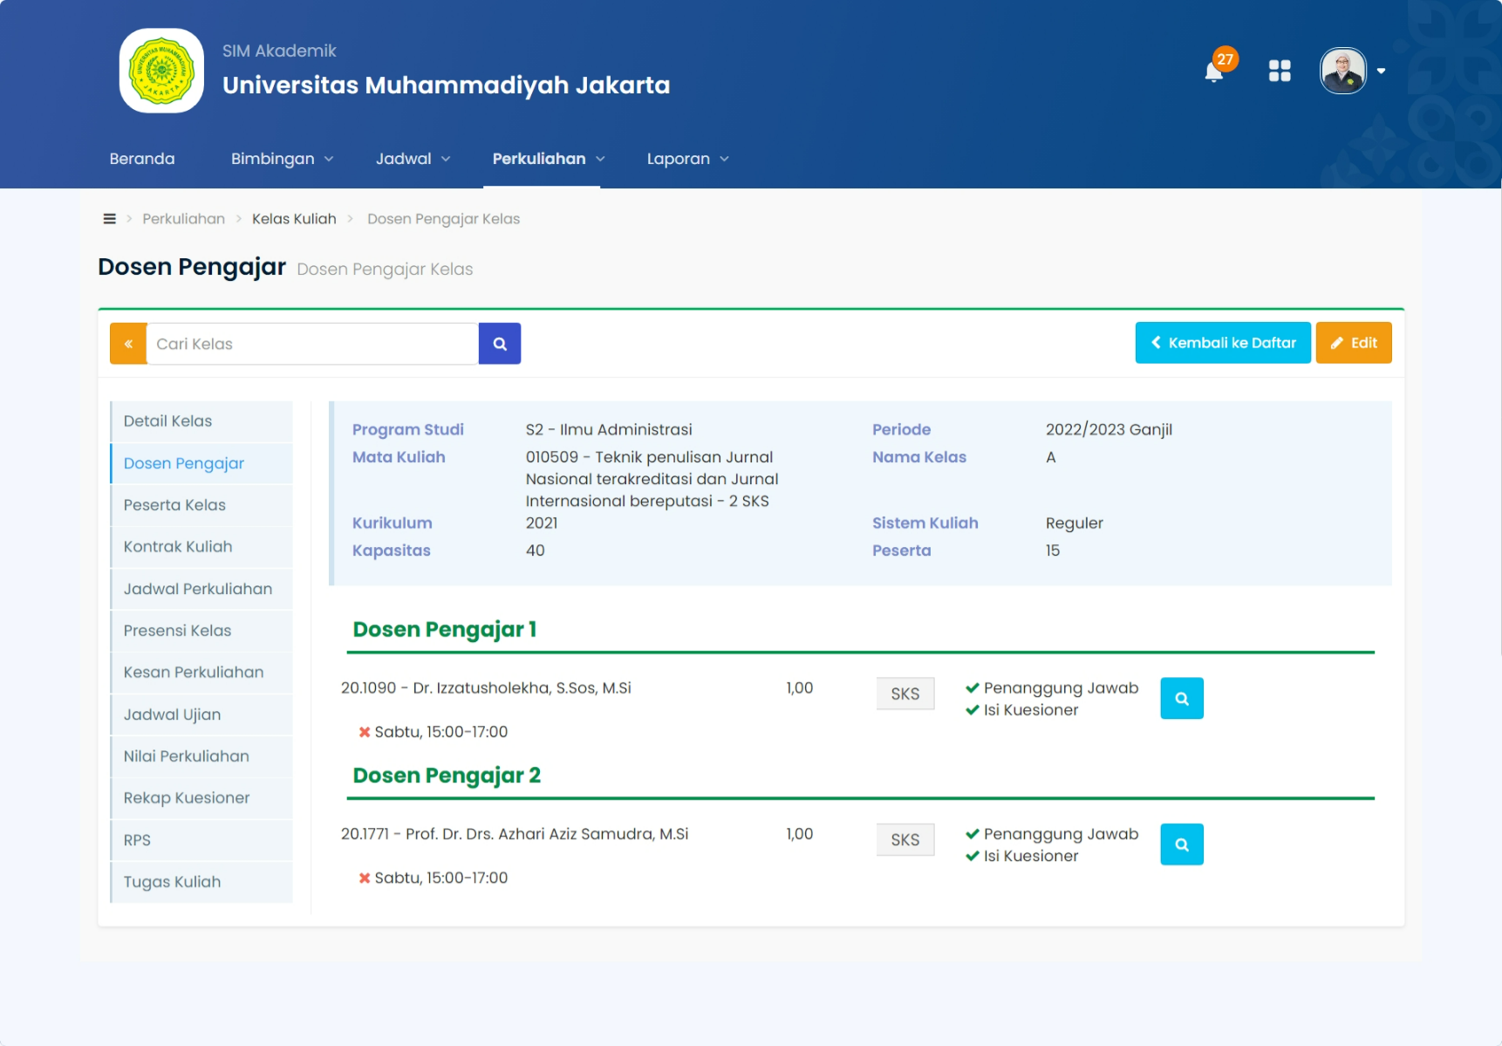
PRESENSI KELAS
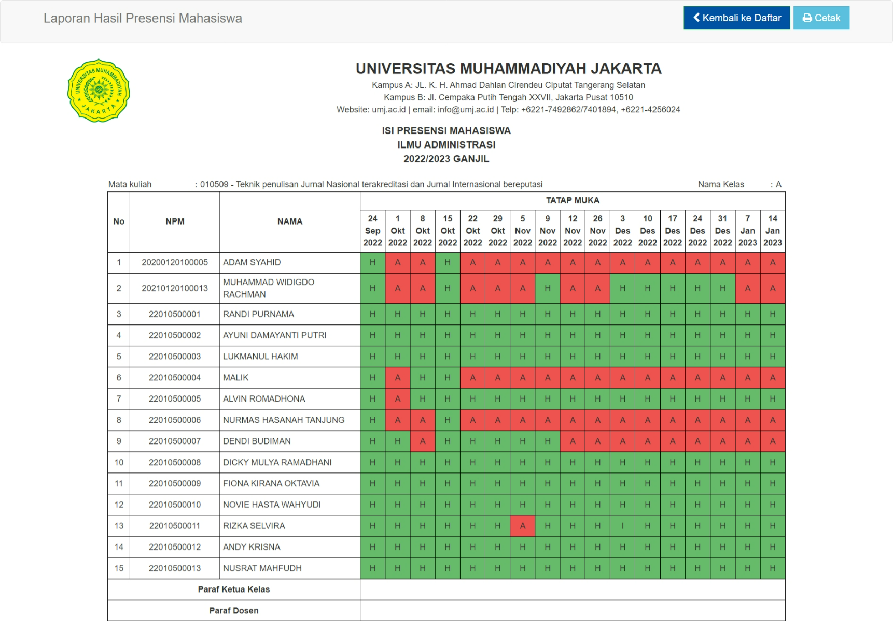
BERITA ACARA PERKULIAHAN
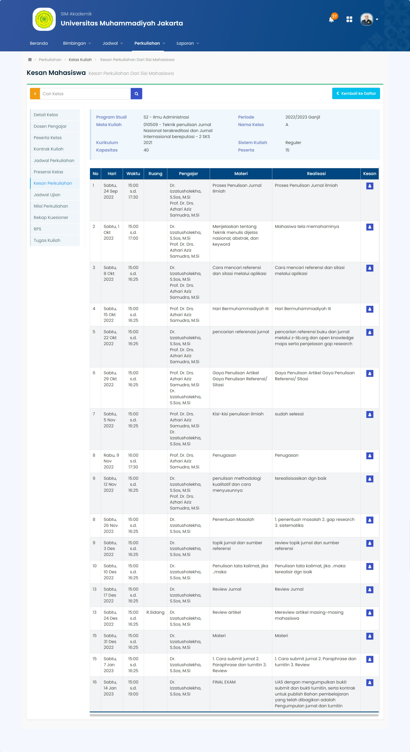

NILAI PERKULIAHAN
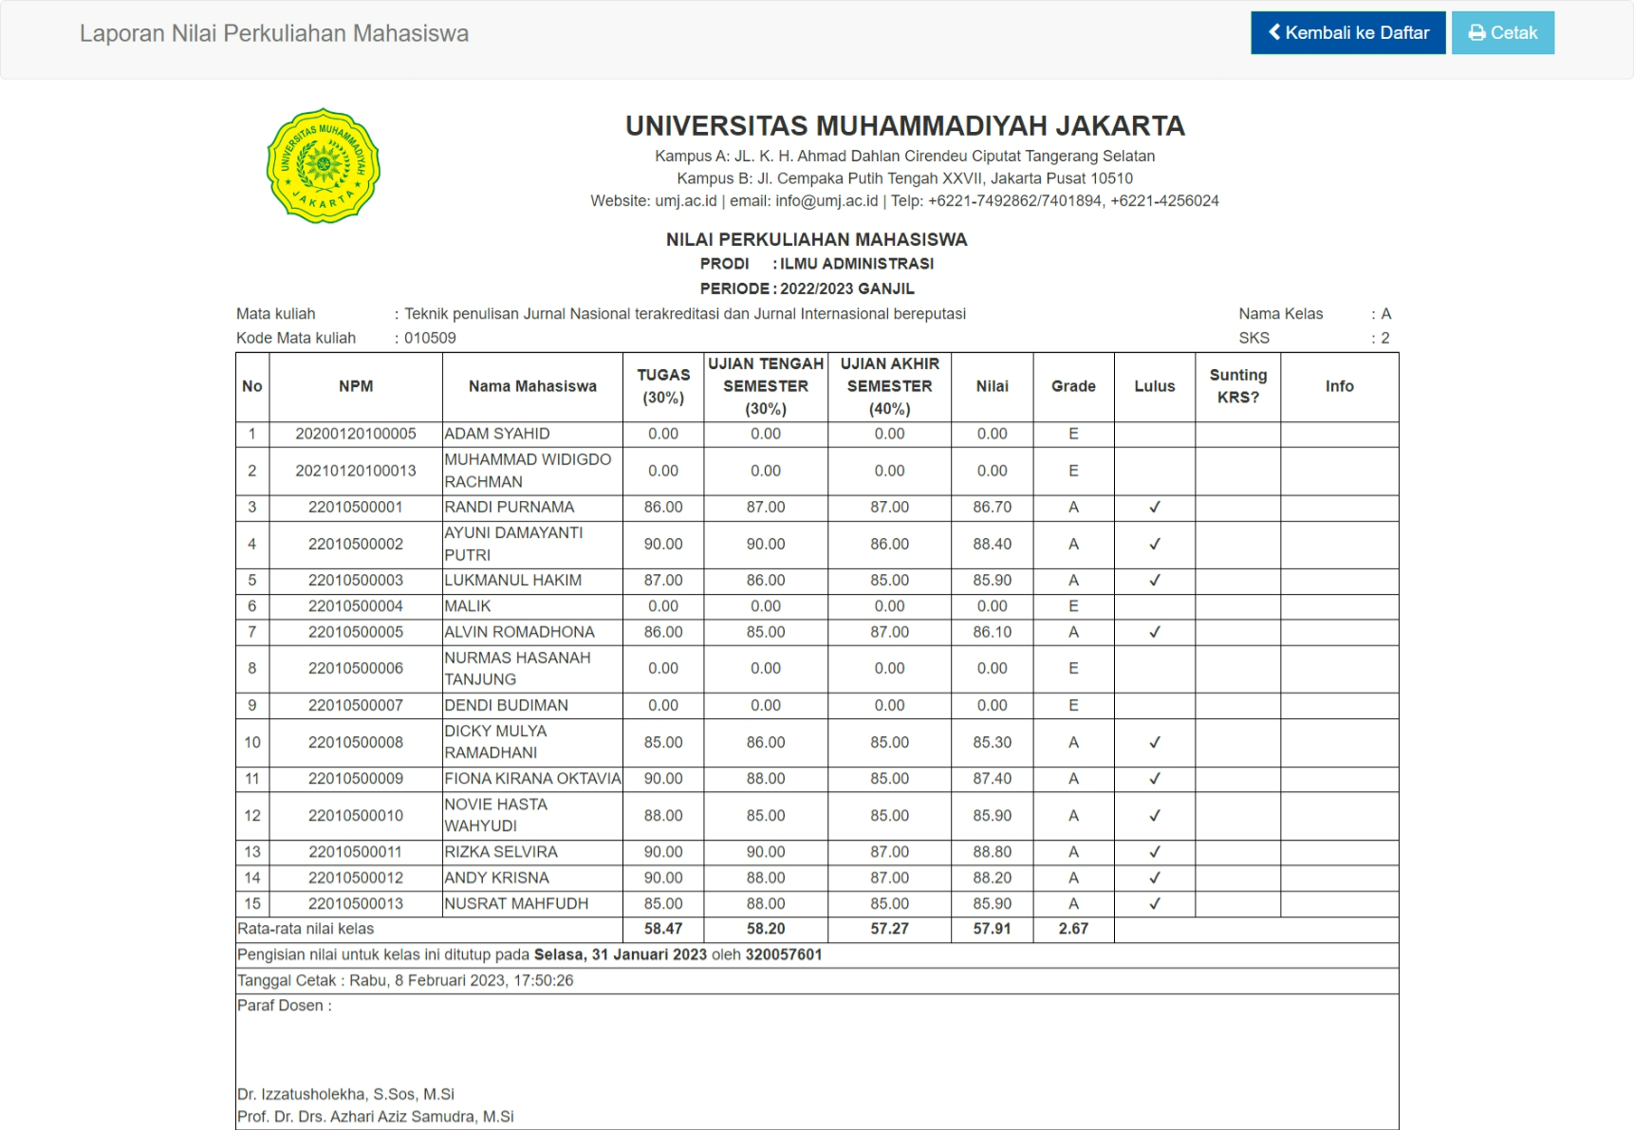

KUISIONER MAHASISWA
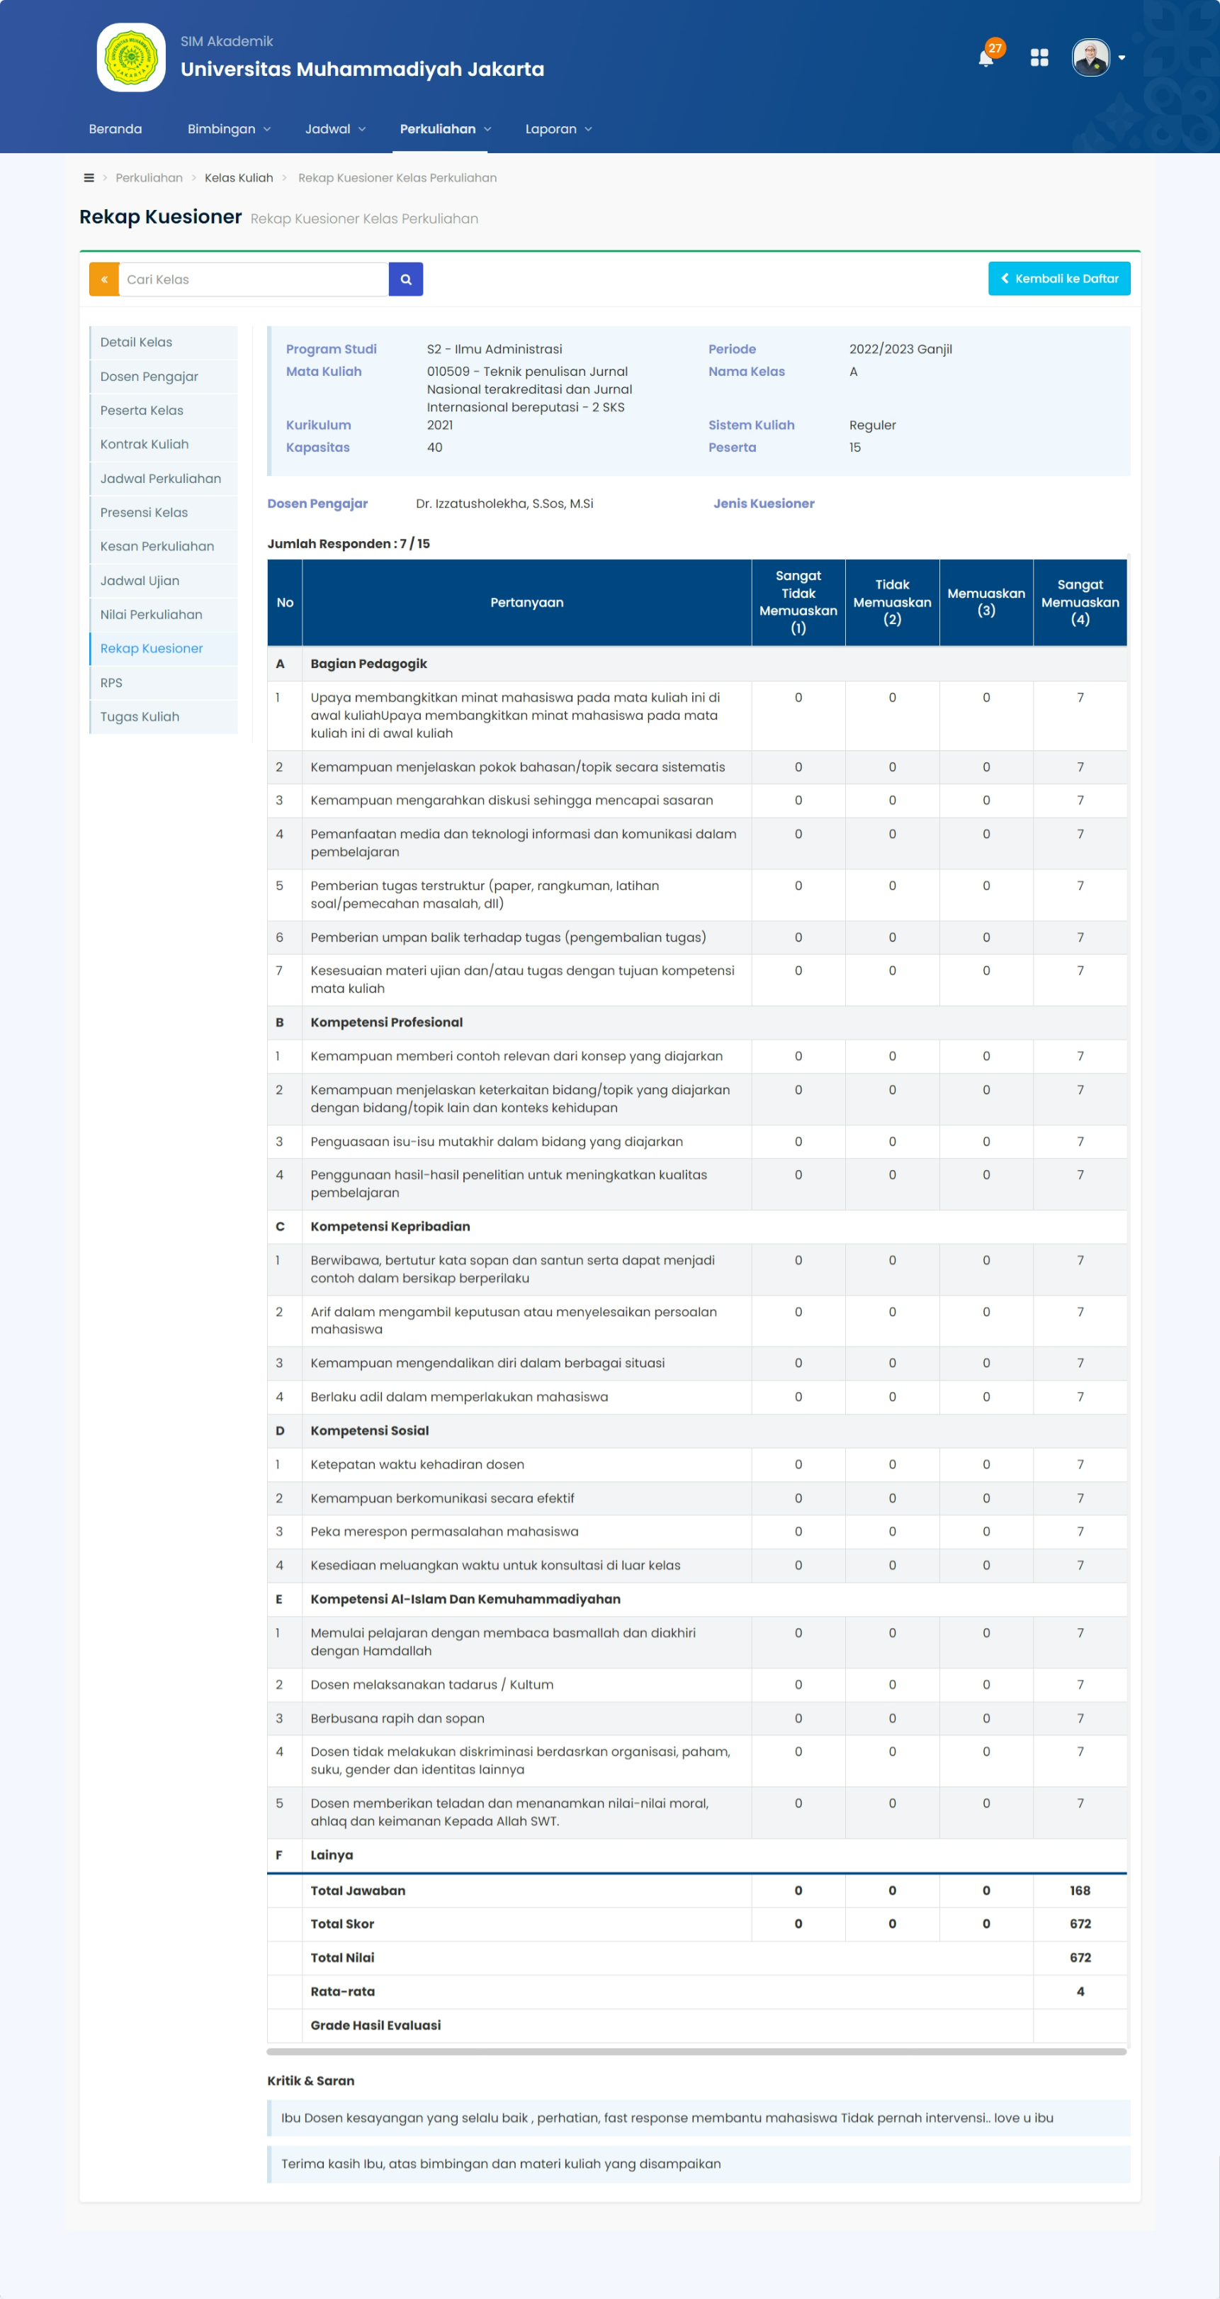

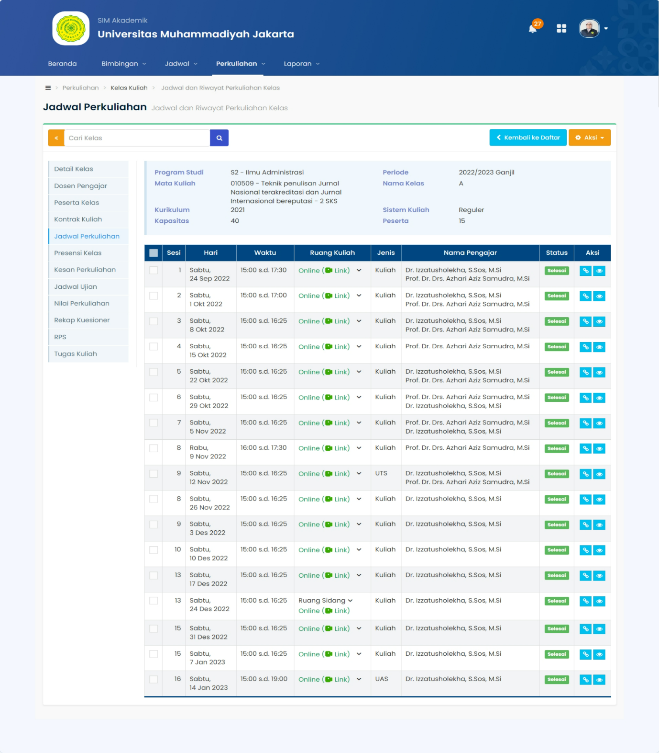

PRESENSI KELAS
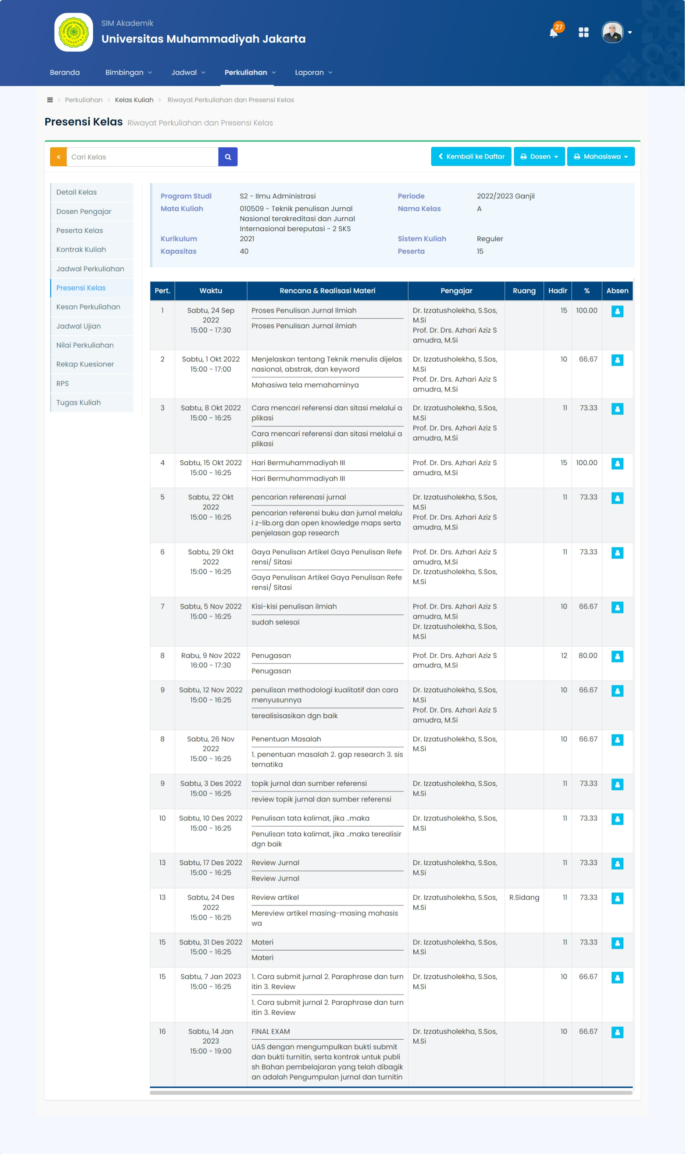
AKTIFITAS KELAS
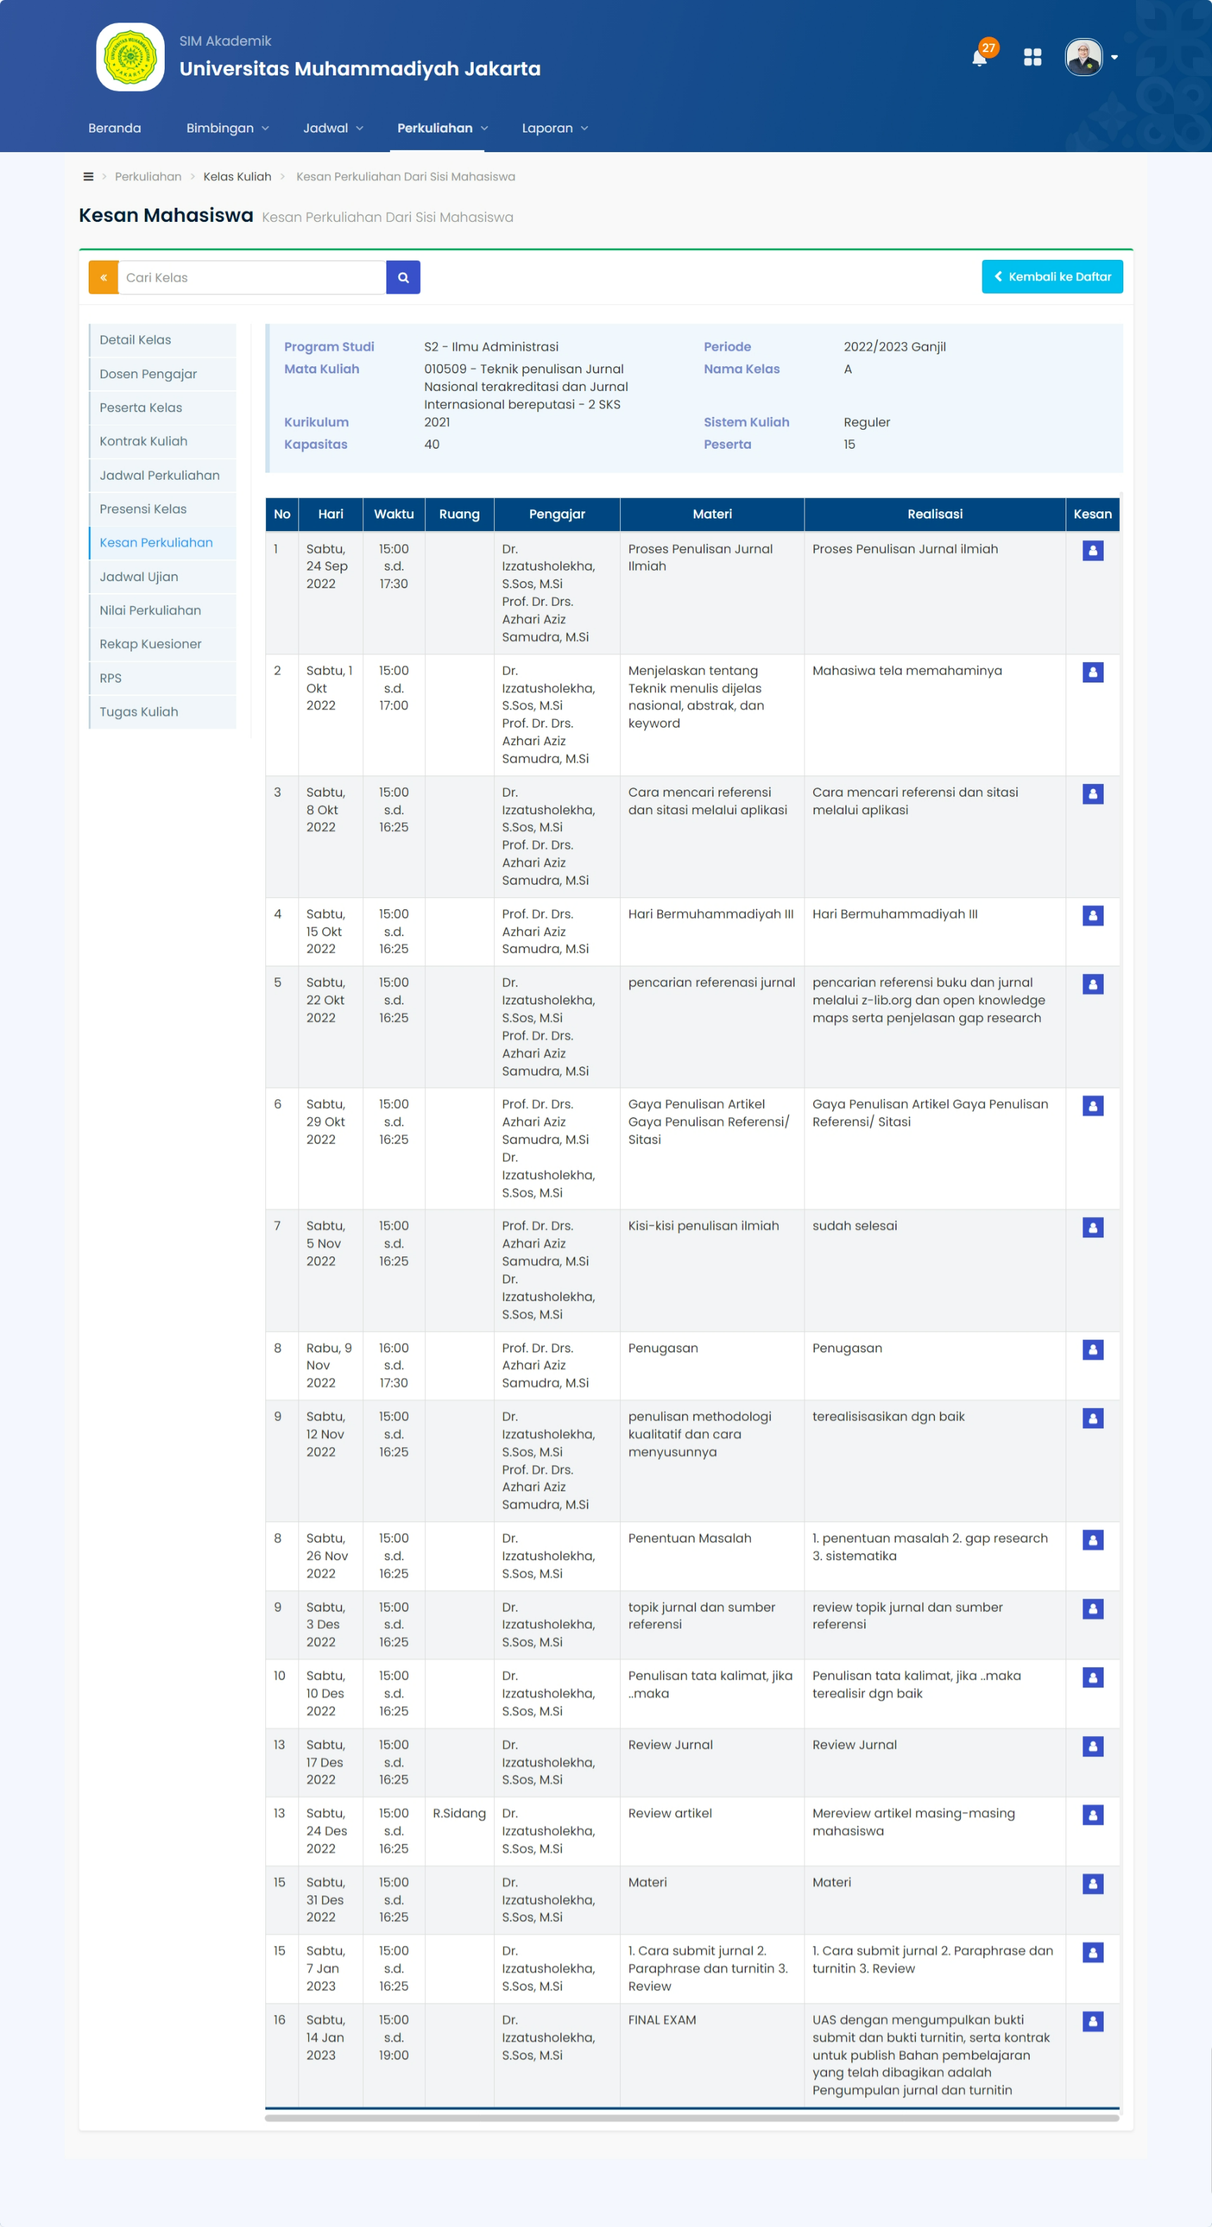
NILAI PERKULIAHAN
No | NPM | Nama | Hadir (%) | TUGAS (30%) | UJIAN TENGAH SEMESTER (30%) | UJIAN AKHIR SEMESTER (40%) | Nilai | Grade
1 | 20200120100005 | ADAM SYAHID | 11.76 | 0.00 | 0.00 | 0.00 | 0.00 | E
2 | 20210120100013 | MUHAMMAD WIDIGDO RACHMAN | 47.06 | 0.00 | 0.00 | 0.00 | 0.00 | E
3 | 22010500001 | RANDI PURNAMA | 100.00 | 86.00 | 87.00 | 87.00 | 86.70 | A
4 | 22010500002 | AYUNI DAMAYANTI PUTRI | 100.00 | 90.00 | 90.00 | 86.00 | 88.40 | A
5 | 22010500003 | LUKMANUL HAKIM | 100.00 | 87.00 | 86.00 | 85.00 | 85.90 | A
6 | 22010500004 | MALIK | 17.65 | 0.00 | 0.00 | 0.00 | 0.00 | E
7 | 22010500005 | ALVIN ROMADHONA | 94.12 | 86.00 | 85.00 | 87.00 | 86.10 | A
8 | 22010500006 | NURMAS HASANAH TANJUNG | 11.76 | 0.00 | 0.00 | 0.00 | 0.00 | E
9 | 22010500007 | DENDI BUDIMAN | 41.18 | 0.00 | 0.00 | 0.00 | 0.00 | E
10 | 22010500008 | DICKY MULYA RAMADHANI | 100.00 | 85.00 | 86.00 | 85.00 | 85.30 | A
11 | 22010500009 | FIONA KIRANA OKTAVIA | 100.00 | 90.00 | 88.00 | 85.00 | 87.40 | A
12 | 22010500010 | NOVIE HASTA WAHYUDI | 100.00 | 88.00 | 85.00 | 85.00 | 85.90 | A
13 | 22010500011 | RIZKA SELVIRA | 94.12 | 90.00 | 90.00 | 87.00 | 88.80 | A
14 | 22010500012 | ANDY KRISNA | 100.00 | 90.00 | 88.00 | 87.00 | 88.20 | A
15 | 22010500013 | NUSRAT MAHFUDH | 100.00 | 85.00 | 88.00 | 85.00 | 85.90 | A

KUISIONER MAHASISWA
