LAPORAN PERKULIAHAN
METODE PENELITIAN KUANTITATIF

Penyusun :Dr. Izzatusholekha, M.Si

PERKULIAHAN SEMSTER GASAL
TA 2022/2023

LAPORAN PERKULIAHAN METODE PENELITIAN KUANTITATIF (KELAS E)
Dosen Pengampu
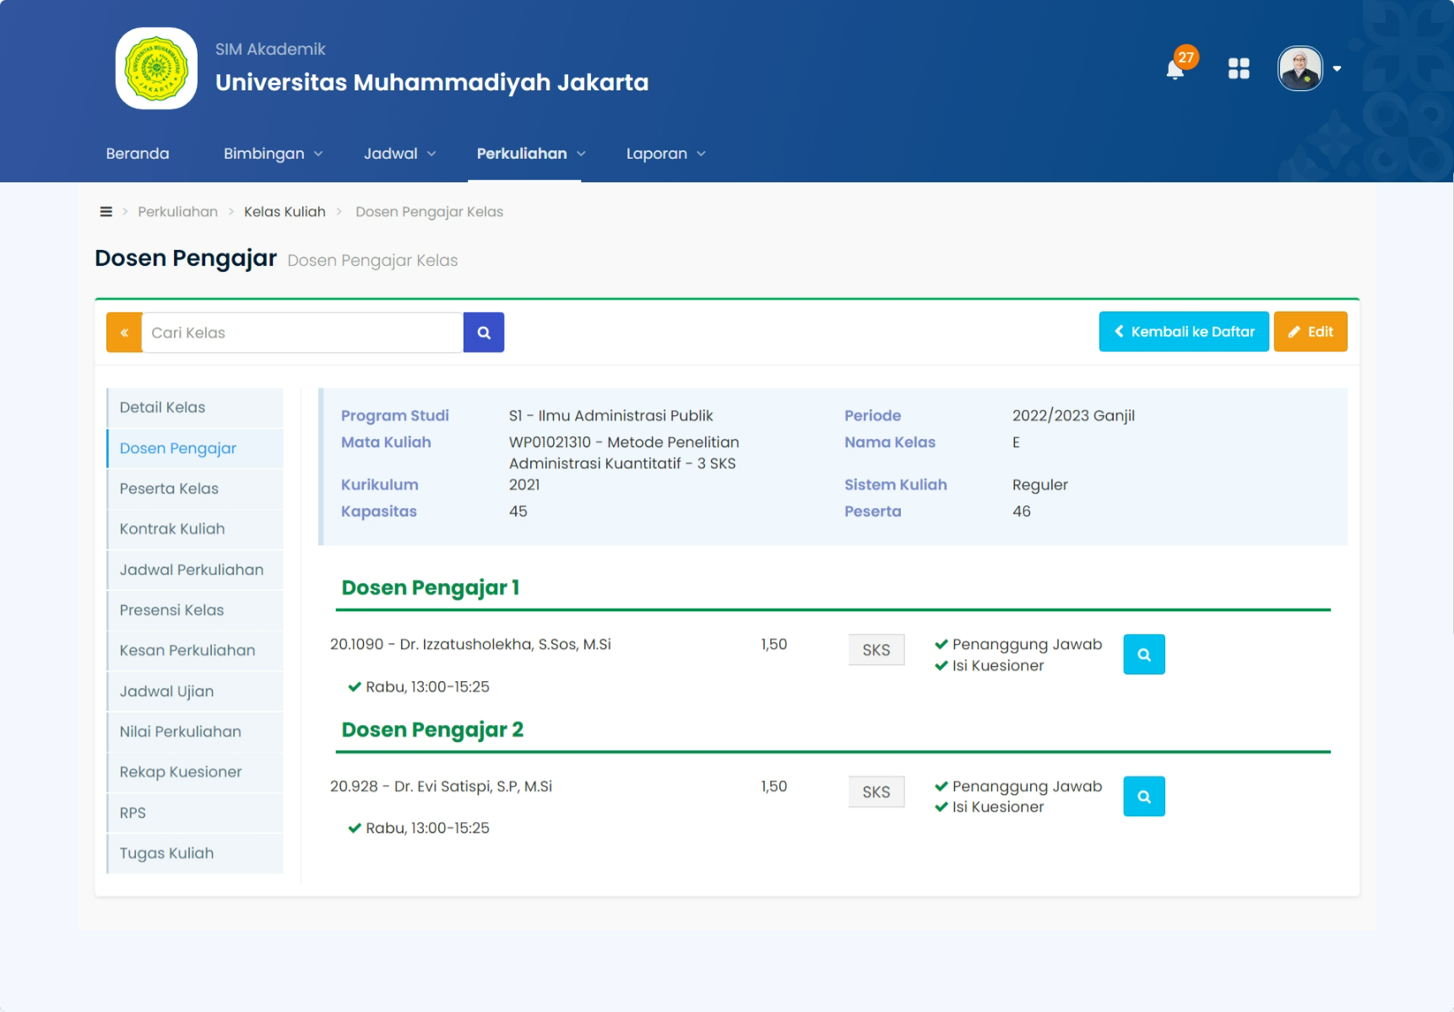

PRESENSI KELAS
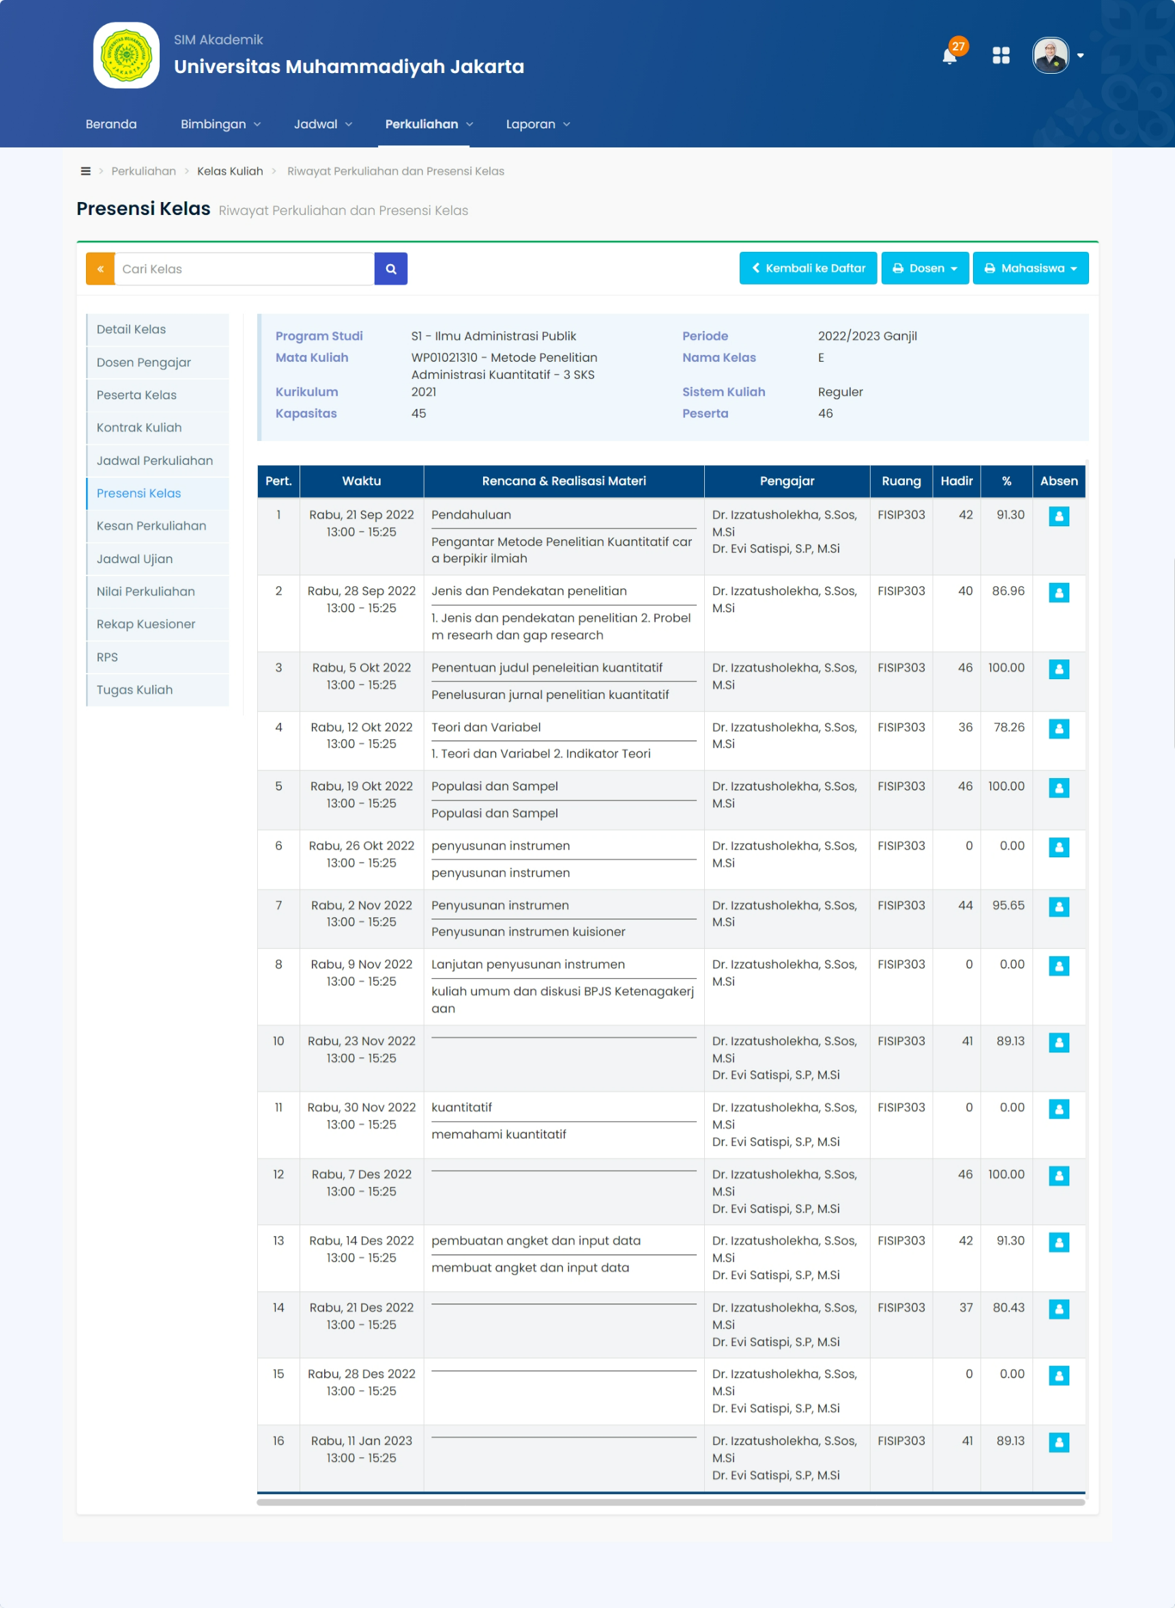
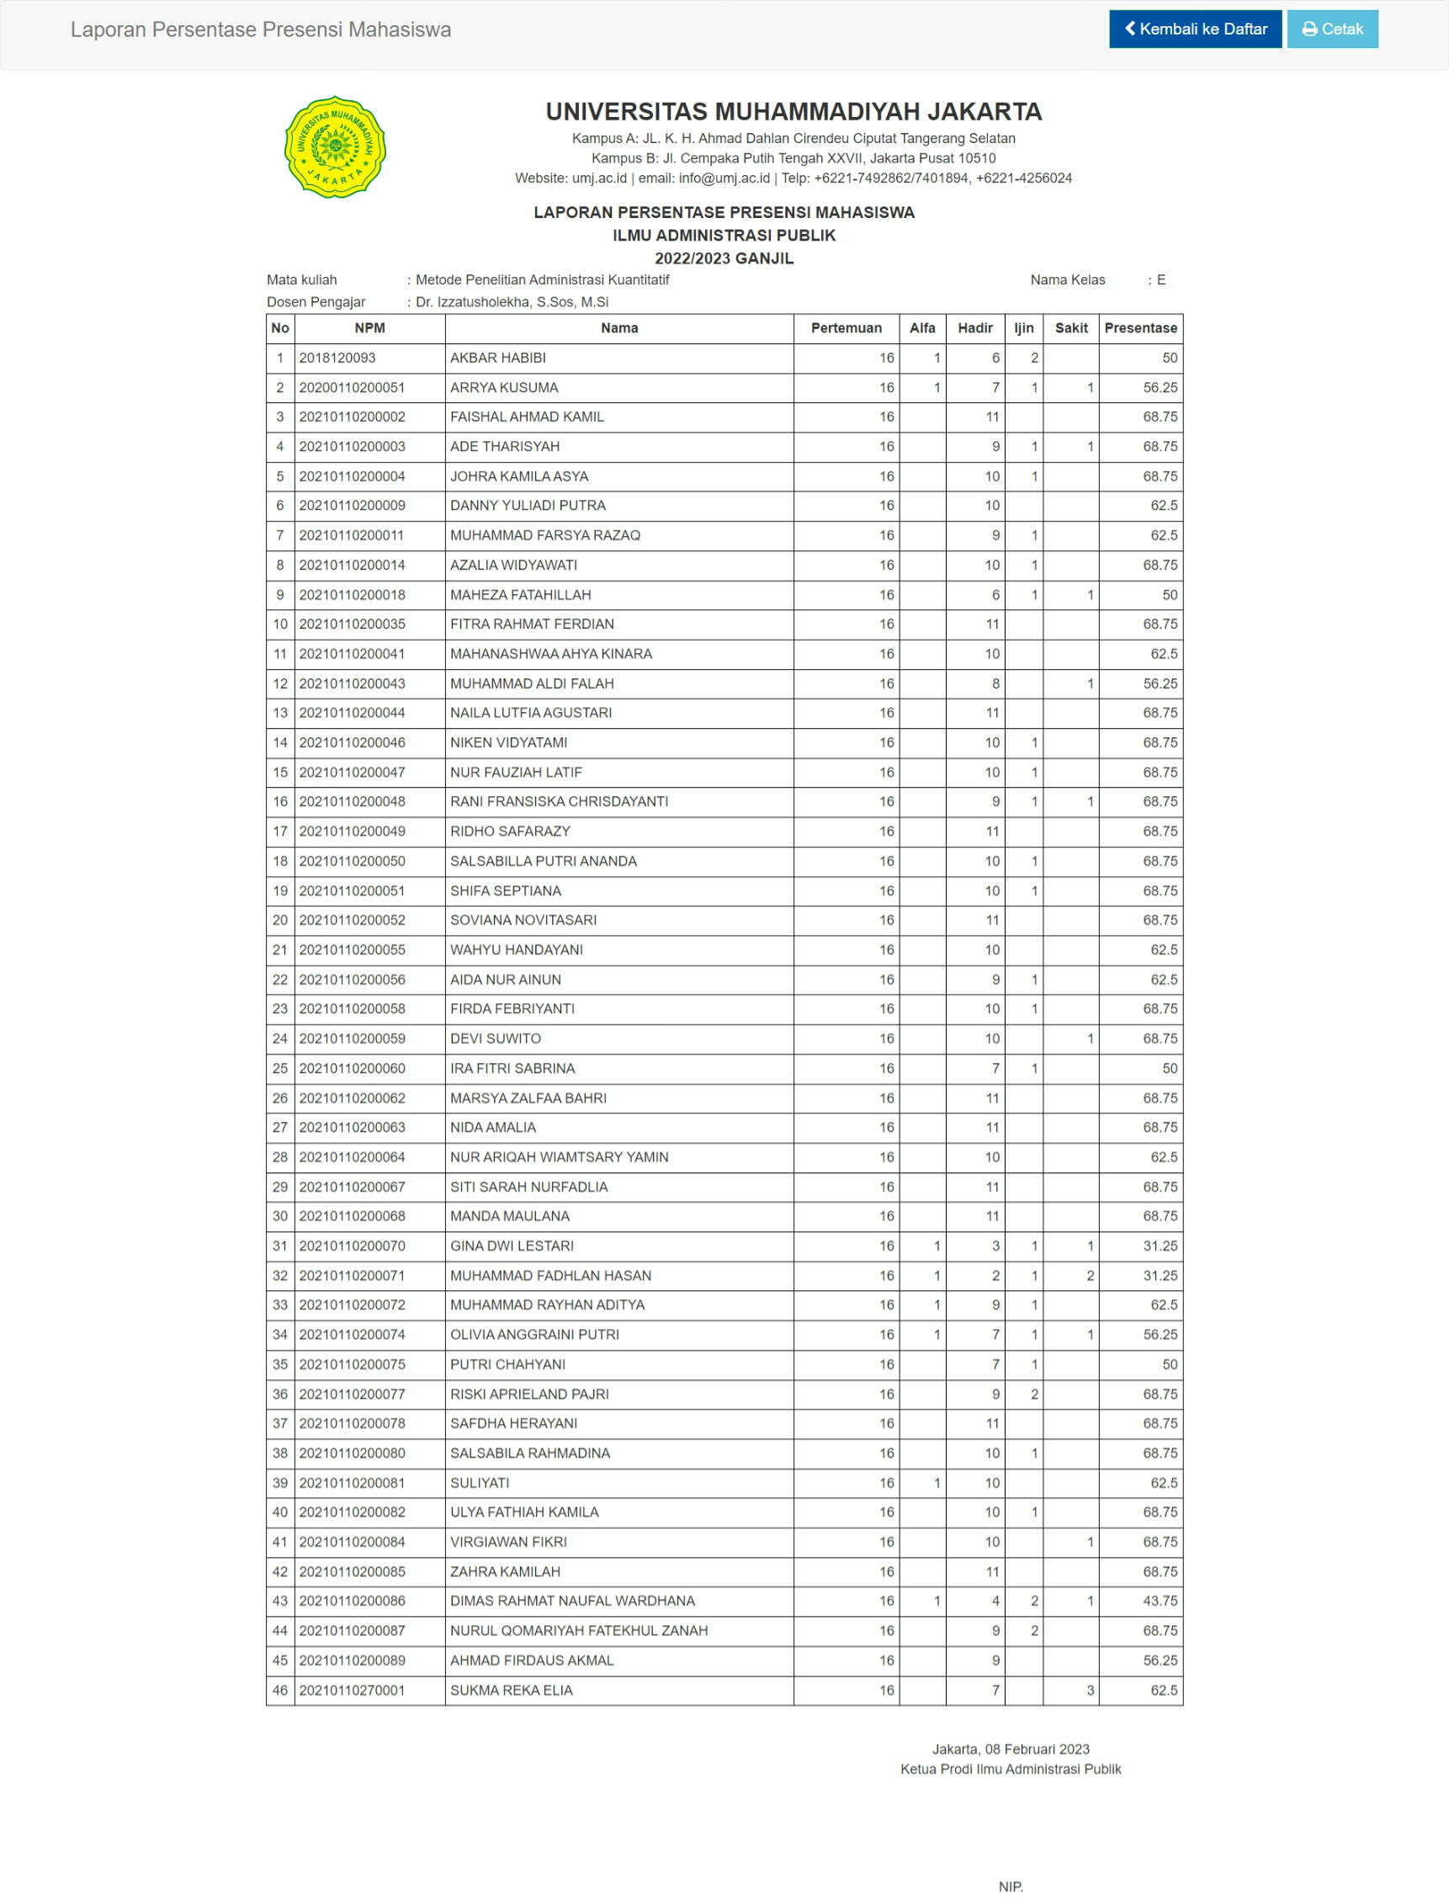

BERITA ACARA PERKULIAHAN
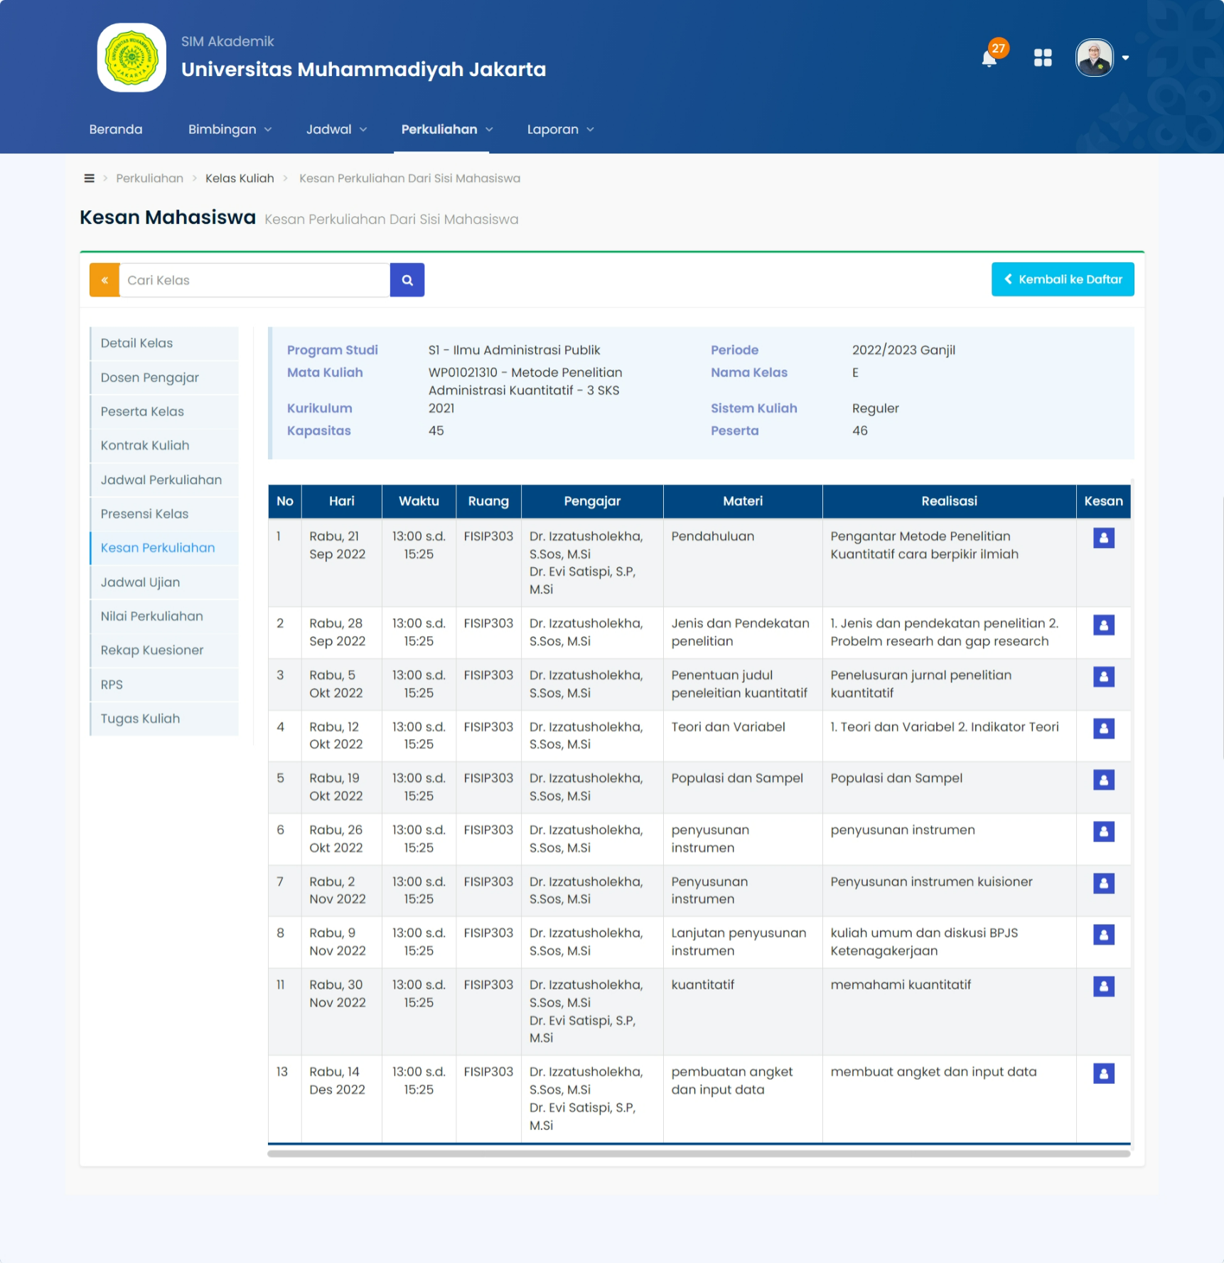

NILAI PERKULIAHAN
No | NPM | Nama | Hadir (%) | TUGAS (30.00%) | UJIAN TENGAH SEMESTER (30.00%) | UJIAN AKHIR SEMESTER (40.00%) | Nilai | Grade
1 | 2018120093 | AKBAR HABIBI | 50.00 | 80.00 | 80.00 | 78.00 | 79.20 | B+
2 | 20200110200051 | ARRYA KUSUMA | 56.25 | 80.00 | 80.00 | 80.00 | 80.00 | A-
3 | 20210110200002 | FAISHAL AHMAD KAMIL | 68.75 | 80.00 | 80.00 | 80.00 | 80.00 | A-
4 | 20210110200003 | ADE THARISYAH | 68.75 | 80.00 | 80.00 | 80.00 | 80.00 | A-
5 | 20210110200004 | JOHRA KAMILA ASYA | 68.75 | 80.00 | 80.00 | 80.00 | 80.00 | A-
6 | 20210110200009 | DANNY YULIADI PUTRA | 62.50 | 80.00 | 80.00 | 85.00 | 82.00 | A-
7 | 20210110200011 | MUHAMMAD FARSYA RAZAQ | 62.50 | 80.00 | 80.00 | 79.00 | 79.60 | B+
8 | 20210110200014 | AZALIA WIDYAWATI | 68.75 | 80.00 | 80.00 | 80.00 | 80.00 | A-
9 | 20210110200018 | MAHEZA FATAHILLAH | 50.00 | 80.00 | 80.00 | 80.00 | 80.00 | A-
10 | 20210110200035 | FITRA RAHMAT FERDIAN | 68.75 | 80.00 | 80.00 | 85.00 | 82.00 | A-
11 | 20210110200041 | MAHANASHWAA AHYA KINARA | 62.50 | 80.00 | 80.00 | 80.00 | 80.00 | A-
12 | 20210110200043 | MUHAMMAD ALDI FALAH | 56.25 | 80.00 | 80.00 | 78.00 | 79.20 | B+
13 | 20210110200044 | NAILA LUTFIA AGUSTARI | 68.75 | 80.00 | 80.00 | 85.00 | 82.00 | A-
14 | 20210110200046 | NIKEN VIDYATAMI | 68.75 | 80.00 | 80.00 | 80.00 | 80.00 | A-
15 | 20210110200047 | NUR FAUZIAH LATIF | 68.75 | 80.00 | 80.00 | 80.00 | 80.00 | A-
16 | 20210110200048 | RANI FRANSISKA CHRISDAYANTI | 68.75 | 80.00 | 80.00 | 79.00 | 79.60 | B+
17 | 20210110200049 | RIDHO SAFARAZY | 68.75 | 80.00 | 80.00 | 79.00 | 79.60 | B+
18 | 20210110200050 | SALSABILLA PUTRI ANANDA | 68.75 | 80.00 | 80.00 | 80.00 | 80.00 | A-
19 | 20210110200051 | SHIFA SEPTIANA | 68.75 | 80.00 | 80.00 | 80.00 | 80.00 | A-
20 | 20210110200052 | SOVIANA NOVITASARI | 68.75 | 80.00 | 80.00 | 80.00 | 80.00 | A-
21 | 20210110200055 | WAHYU HANDAYANI | 62.50 | 80.00 | 80.00 | 85.00 | 82.00 | A-
22 | 20210110200056 | AIDA NUR AINUN | 62.50 | 80.00 | 80.00 | 78.00 | 79.20 | B+
23 | 20210110200058 | FIRDA FEBRIYANTI | 68.75 | 80.00 | 80.00 | 79.00 | 79.60 | B+
24 | 20210110200059 | DEVI SUWITO | 68.75 | 80.00 | 80.00 | 80.00 | 80.00 | A-
25 | 20210110200060 | IRA FITRI SABRINA | 50.00 | 80.00 | 80.00 | 79.00 | 79.60 | B+
26 | 20210110200062 | MARSYA ZALFAA BAHRI | 68.75 | 80.00 | 80.00 | 80.00 | 80.00 | A-
27 | 20210110200063 | NIDA AMALIA | 68.75 | 80.00 | 80.00 | 80.00 | 80.00 | A-
28 | 20210110200064 | NUR ARIQAH WIAMTSARY YAMIN | 62.50 | 80.00 | 80.00 | 78.00 | 79.20 | B+
29 | 20210110200067 | SITI SARAH NURFADLIA | 68.75 | 80.00 | 80.00 | 80.00 | 80.00 | A-
30 | 20210110200068 | MANDA MAULANA | 68.75 | 80.00 | 80.00 | 80.00 | 80.00 | A-
31 | 20210110200070 | GINA DWI LESTARI | 31.25 | 80.00 | 80.00 | 75.00 | 78.00 | B+
32 | 20210110200071 | MUHAMMAD FADHLAN HASAN | 31.25
33 | 20210110200072 | MUHAMMAD RAYHAN ADITYA | 62.50 | 80.00 | 80.00 | 80.00 | 80.00 | A-
34 | 20210110200074 | OLIVIA ANGGRAINI PUTRI | 56.25 | 80.00 | 80.00 | 78.00 | 79.20 | B+
35 | 20210110200075 | PUTRI CHAHYANI | 50.00 | 80.00 | 80.00 | 78.00 | 79.20 | B+
36 | 20210110200077 | RISKI APRIELAND PAJRI | 68.75 | 80.00 | 80.00 | 80.00 | 80.00 | A-
37 | 20210110200078 | SAFDHA HERAYANI | 68.75 | 80.00 | 80.00 | 80.00 | 80.00 | A-
38 | 20210110200080 | SALSABILA RAHMADINA | 68.75 | 80.00 | 80.00 | 80.00 | 80.00 | A-
39 | 20210110200081 | SULIYATI | 62.50 | 80.00 | 80.00 | 78.00 | 79.20 | B+
40 | 20210110200082 | ULYA FATHIAH KAMILA | 68.75 | 80.00 | 80.00 | 79.00 | 79.60 | B+
41 | 20210110200084 | VIRGIAWAN FIKRI | 68.75 | 80.00 | 80.00 | 80.00 | 80.00 | A-
42 | 20210110200085 | ZAHRA KAMILAH | 68.75 | 80.00 | 80.00 | 80.00 | 80.00 | A-
43 | 20210110200086 | DIMAS RAHMAT NAUFAL WARDHANA | 43.75
44 | 20210110200087 | NURUL QOMARIYAH FATEKHUL ZANAH | 68.75 | 80.00 | 80.00 | 79.00 | 79.60 | B+
45 | 20210110200089 | AHMAD FIRDAUS AKMAL | 56.25 | 80.00 | 80.00 | 85.00 | 82.00 | A-
46 | 20210110270001 | SUKMA REKA ELIA | 62.50 | 80.00 | 80.00 | 80.00 | 80.00 | A-
JAKARTA, 2 Februari 2023
Dosen Pengampu Mata Kuliah

KUISIONER MAHASISWA
